**OBJECT ORIENTED PROGRAMMING USING C++**

**BCA-253**

**PRACTICAL QUESTIONS FOR BCA-3A AND BCA-3B**

1. Write a Program to find greatest of three numbers using Ternary Operator
2. Write a Program to read a floating point number and print Integer and Float part of the number separately
3. Write a Program to calculate displacement using formulae s=ut+1/2at2 given values of a,u,t by the user
4. Write a Program to check weather a number is Even or Odd
5. Write a Program to print table of a number
6. Write a Program to print factorial of a number
7. Write a Program to print the following Pattern

5 5 5 5 5

4 4 4 4

3 3 3

2 2

1

1. Write a Program to print the following Pattern

1

1 2

1 2 3

1 2 3 4

1. Write a Program to swap two numbers without using the third variable
2. Write a Program to check weather a string is Palindrome or not
3. Write a Program to calculate sum and sum of squares of first 15 Even Numbers
4. Write a Program to check weather a number is prime or not
5. Write a Program to convert Binary Number to Decimal Number
6. Write a Program to check weather a number is Armstrong or not
7. Write a Program to calculate Simple Interest using the concept of classes
8. Write a Program to illustrate the concept of Static Member Data and Static Member Function
9. Write a Program to make a Simple Calculator using the concept of classes
10. Write a Menu Driven Program to Add, Subtract, Multiply two matrices of order 2X2 using concepts of Object Oriented Programming.
11. Write a Program to show the concept of Scope Resolution and Scope of Variables
12. Write a Program to swap two integer values, two floating point values, two character values using function overloading
13. Make an inline function to find square of a number
14. Write a Program to add two complex numbers
15. By primary objects or function arguments.
16. By returning objects
17. Write a Program by illustrating concepts of passing objects
18. By reference
19. By pointers
20. Write a Program to illustrate the concept of Friend Function and Friend Class
21. Write a Program which reads a complex number and copies that to another using copy constructor
22. Write a Program which reads two complex numbers, initialize objects with these two numbers and find multiplication of these using parametrized constructors.
23. Write a Program to illustrate concept of destructors
24. Write a Program to illustrate concept of constructor overloading
25. Write a Program to illustrate usage of constructors with default arguments
26. Write a C++ program handling following details of a student and staff using inheritance
27. Student details: Name, Address, Percentage, Marks
28. Staff details: Name, Address, Salary

Create appropriate base and derived classes. Input the details and output them

1. Write a Program to implement the inheritance as shown in figure. Assume a suitable member function to accept and display data.

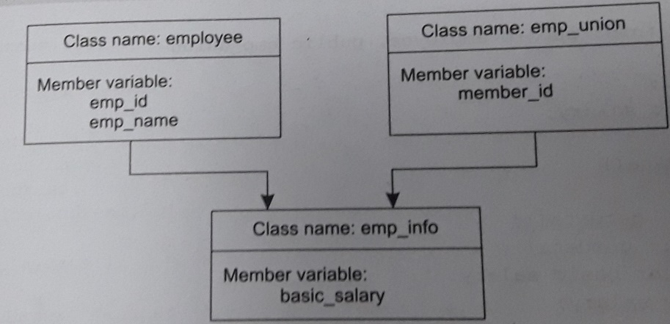

1. Consider a scenario where it is required to design a class named matrix for storing matrix elements. The size of the matrix is specified at run time on the basis of which class constructor reserves memory space using dynamic memory allocation technique. Implement it by writing a suitable program.
2. Write a Program to illustrate concept of constructors in derived class in which no constructor is used in base class and derived class
3. Write a Program to illustrate concept of constructors in derived class in which constructor is used only in base class
4. Write a Program to illustrate concept of constructors in derived class in which constructor is used only in derived class
5. Write a Program to illustrate concept of constructors in derived class in which constructor is used in both base class and derived class
6. Write a Program to illustrate concept of constructors in derived class in which multiple constructors are used in base class and single constructor is used in derived class
7. Write a Program to illustrate concept of constructors in derived class in which constructor is used in base class and derived class without default constructor
8. Write a Program to illustrate concept of constructors in derived class in which Explicit invocation is there in absence of default constructor
9. Write a Program to illustrate concept of constructors in derived class in which constructors are used in a multiple inherited class with default invocation
10. Write a Program to illustrate concept of constructors in derived class in which constructors are used in a multiple inherited class with explicit invocation
11. Write a Program to illustrate concept of constructors in derived class in which constructor is used in base class and derived class in multiple inheritance
12. Write a Program to illustrate concept of constructors in derived class in which constructor is used in multilevel inheritance
13. Identify the type of inheritance and implement it by modelling the Examination Database

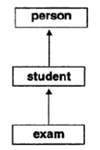

1. Consider a publishing company that publishes and markets books, whose activities are shown. Create a class publication that stores the title and price of a publication. Create another class sales that holds an array of three float’s so that it can record the sales of a publication for the last three months. For these two classes, derive a new class called book that holds pages of integer type. Each of the classes should have member functions getdata( ) and display( ).

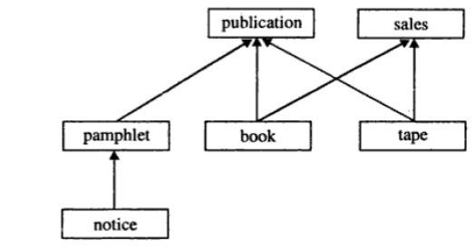

1. Which type of inheritance is this? Illustrate this inheritance by writing a program assuming your own data members.

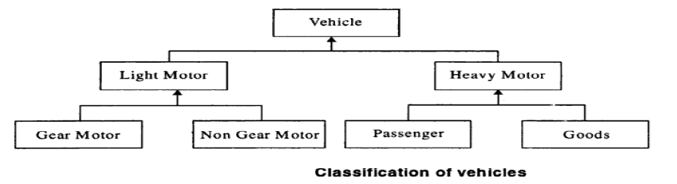

1. Illustrate the concept of Multipath Inheritance and Virtual Base Class by focusing on following relation:

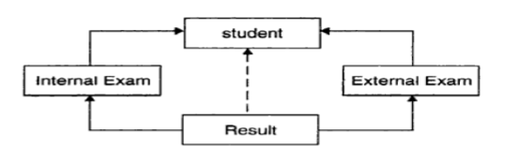

1. Identify the type of inheritance and implement the following relation:

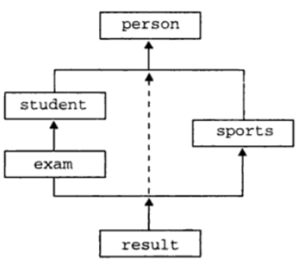

1. Write a Program to overload Unary Operators
2. Write a Program to overload Binary Operator using Friend Function
3. Write a Program to Concatenate two Strings using Operator Overloading
4. Write a Program to show the concept of Virtual functions.